PSI901A-- Physical Space Inventory Rooms by Room Type 5/16/13 v2 jml
This report provides a building or organization room list by room type with Org FY Net Area.

The report is on the PSI tab, below report 901
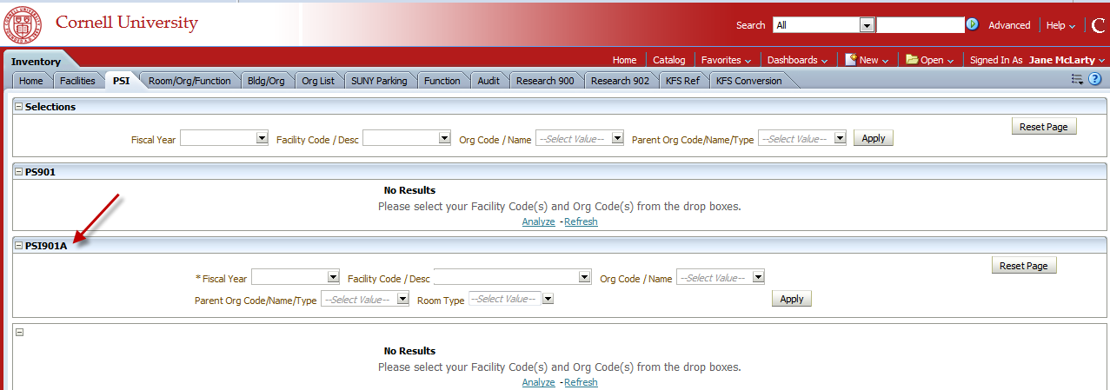

Required search limits: Facility Code – Individual Facility Codes or “All Column Values” for no Facility Code limits Fiscal Year

Optional additional limits: Org Code
Parent Org code
Room Type

Facility Code(s) determines the values in the remaining drop down selection boxes; values are limited by the attributes of the selected Facility(s). If you choose not to limit your report by Facility Code, choose “All Column Values”.

In this example I’ve limited the Facility Code using “All Column Values” – all Orgs are shown in the values of the Org Code Drop Down
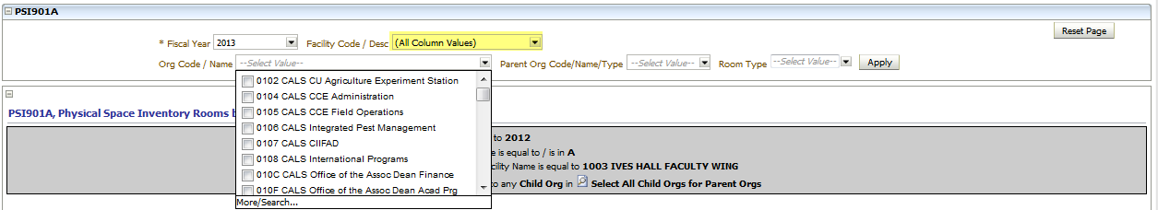

In this example I’ve limited the report to Facility 2023, only Orgs that have a presence in facility 2023 are shown in the values of the Org Code Drop Down.
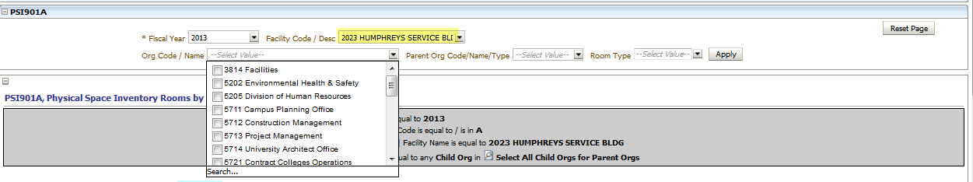
Columns in the report can be reordered; move your mouse over the header of the column you would like to move, when the tab appears, drag and drop.
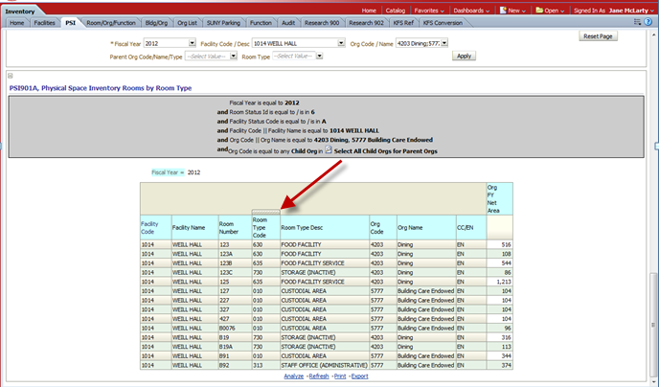

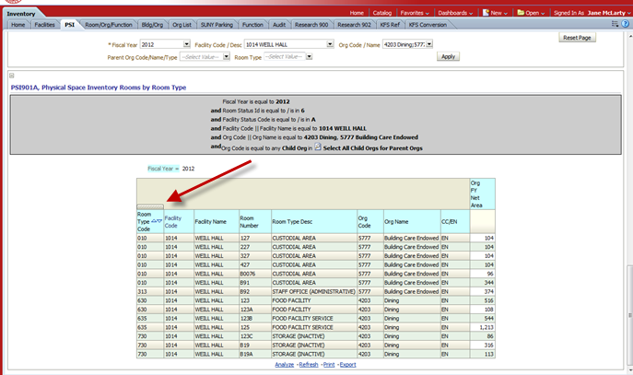

The report is sorted by column from left to right. Columns can be sorted by ascending or descending order; the default sort is ascending. To change the sort order click on the arrow next to the column name. ▲Sort ascending, ▼descending.
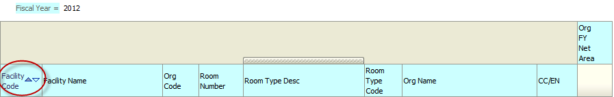

In this example, all the columns are sorted in ascending order.
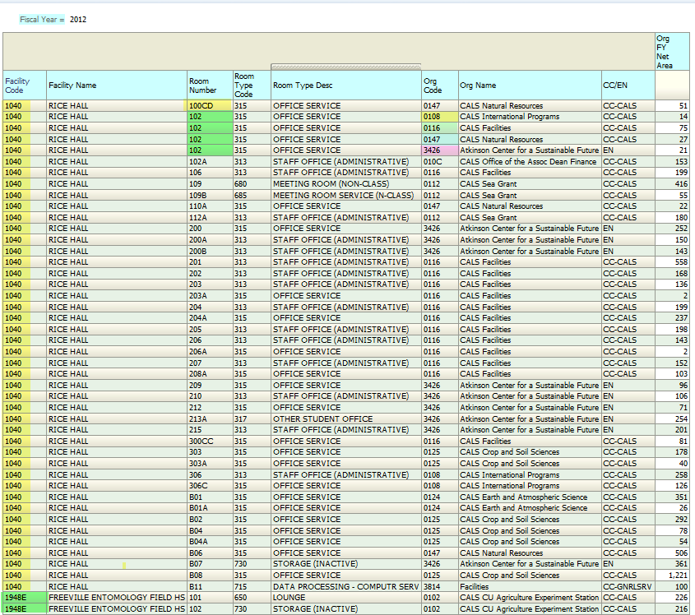
Facility Code is the first sort, Room Numbers are sorted within Facility Codes, Org Codes are sorted within Room Numbers… Because Rooms only have one Room Type, the Room Type sort within Room Numbers has no effect.

Move “Org Code to the First Column and It becomes the primary sort.
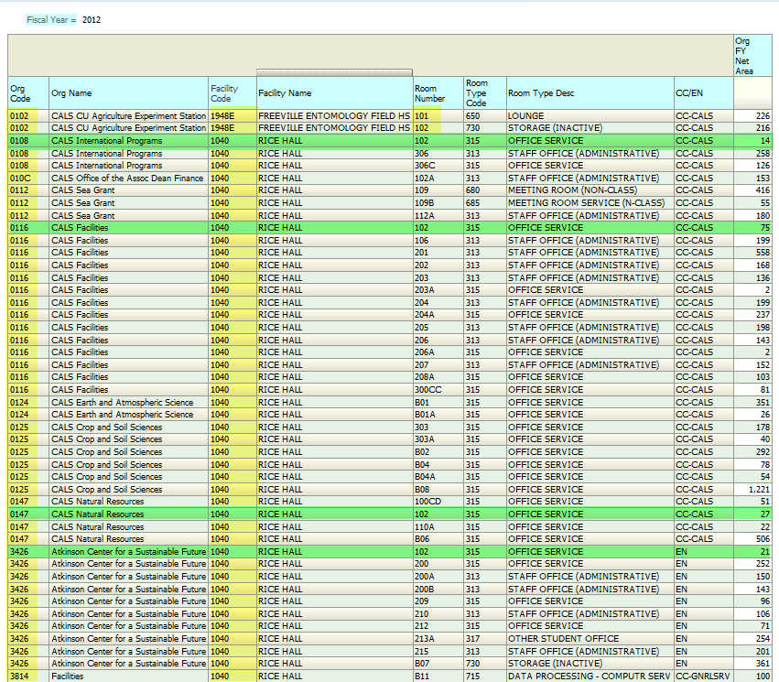
Room 102 in Rice Hall is now sorted by Org Code

Subtotals can be added, and columns can be hidden or excluded from view.
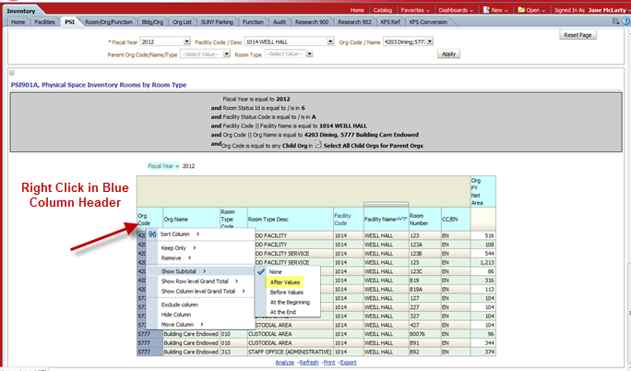

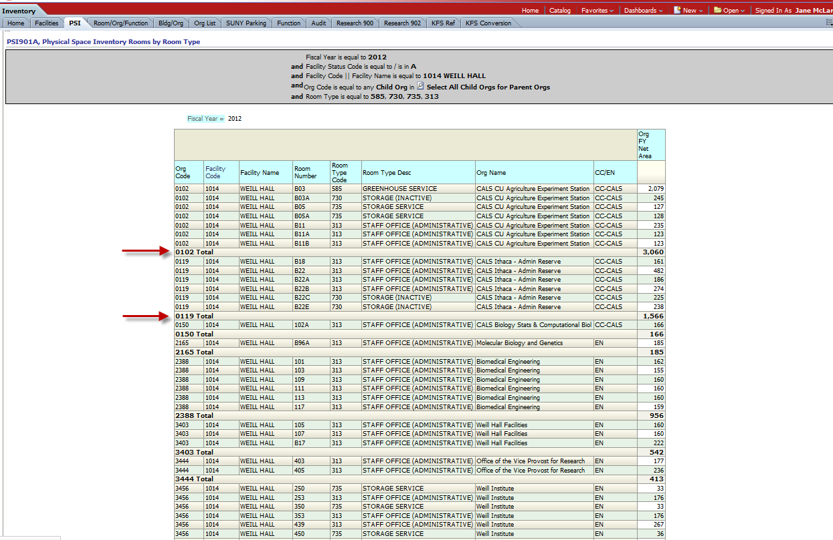

To clear subtotals, check none
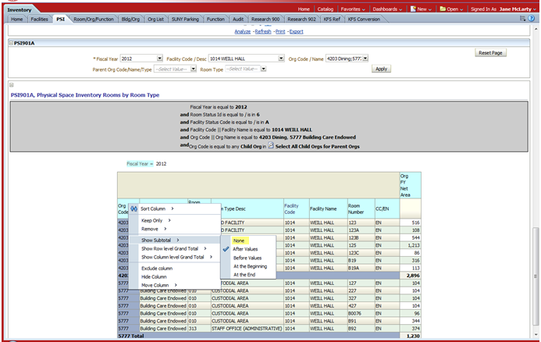

In this example I’ve excluded the column Facility Name
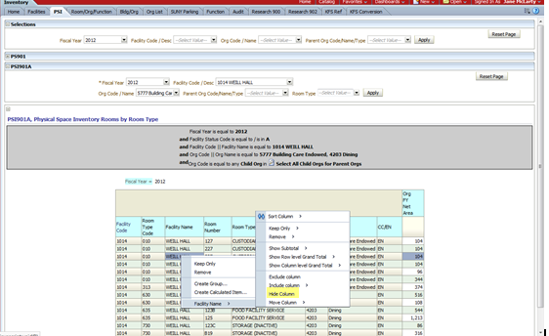

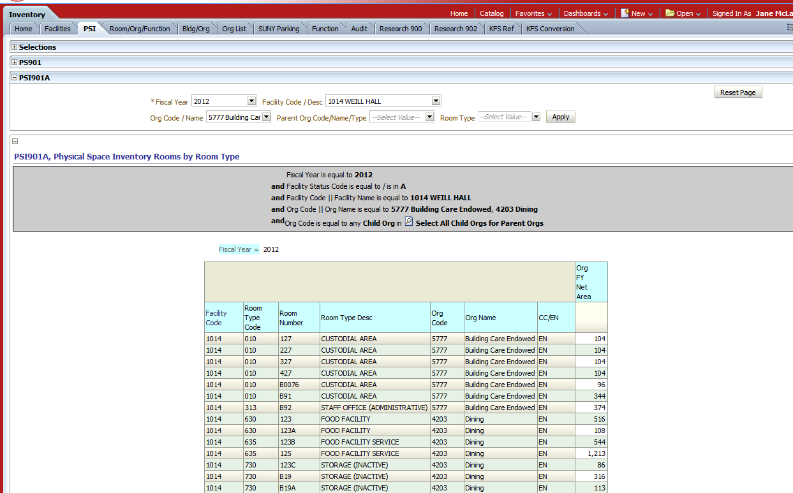

To un-exclude it, select “Include Column”, and choose “Facility Name”.
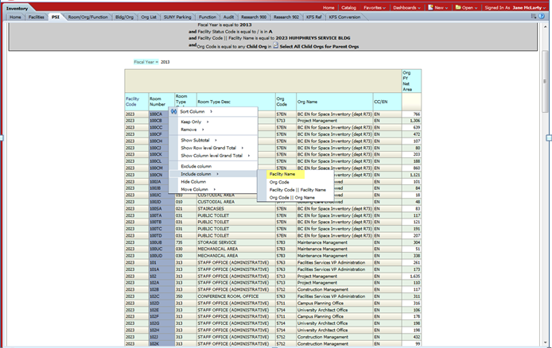

When exported as data, hidden/excluded columns are exported, but subtotals are not. When exported as Excel or a PDF, hidden/excluded columns are not included, but subtotals are.

