FI Renovations SharePoint Site Instructions
11/1/13 v3-SV

To log into the site, enter your netid & password.
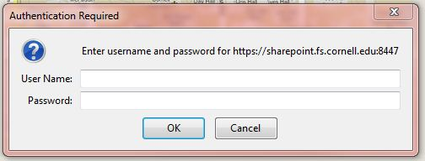

- ACCESS THE RENOVATION PDF’S:
- To access the floor plans of renovations that affect your org, click on the appropriate document library.
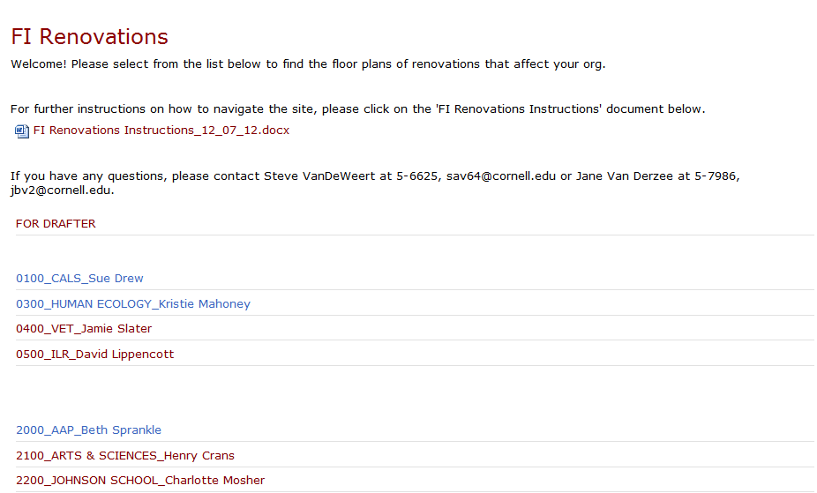
- This will open the document library and display folders organized by facility code_facility name. Click on a folder to show the renovation PDF’s for that facility.
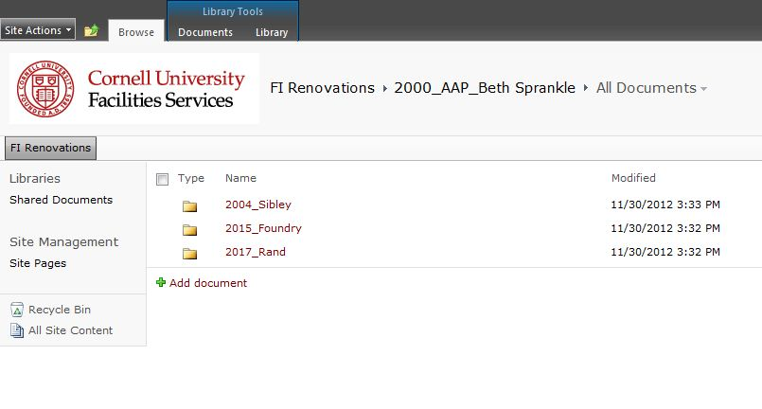

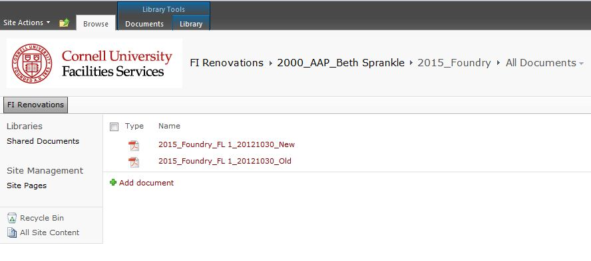

- IF YOU CLICK ON A PDF FILE, BE AWARE THAT IT WILL OPEN IN THE SAME BROWSER. To get back, click the back button.
OR
- To open a file in a new window, right click on the file name, and select ‘Open Link in New Window’.

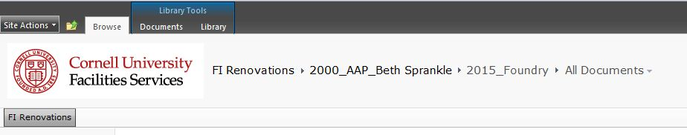
- To go back to the main FI Renovations page, click one of the following locations:

- ‘FOR DRAFTER’ DOCUMENT LIBRARY
If you have a renovation you know about in your facility and would like to provide Facilities Inventory with a marked up floor plan, please add it to the FOR DRAFTER library.
- On the main page, click the FOR DRAFTER document Library.
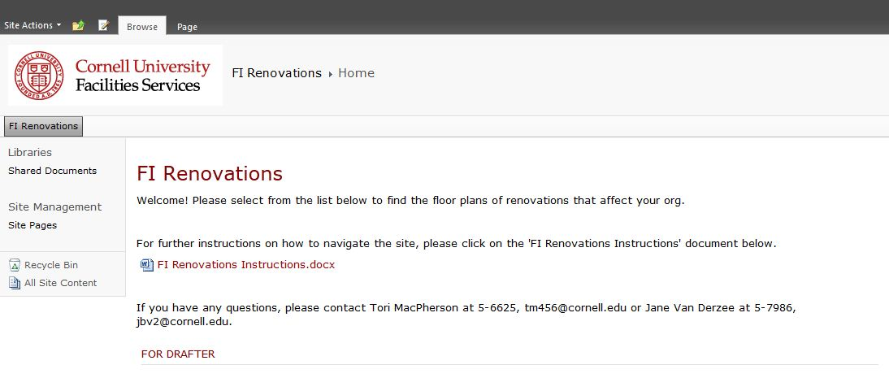

- Add a document by clicking ‘+Add document’
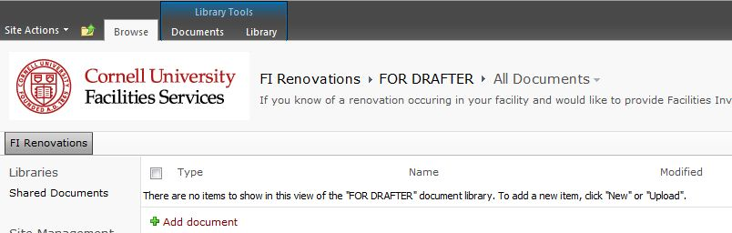

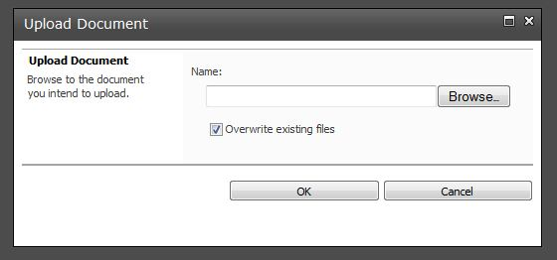
- You will be prompted to upload a document.

- Please label the file as follows:
Facility code_facility name_FL #_date(yyyymmdd)_to-do
Example: 2023_Humphreys_FL 2_20121101_to-do

- ACCESSING LINKS
- On the main page, click on the link you would like to open.
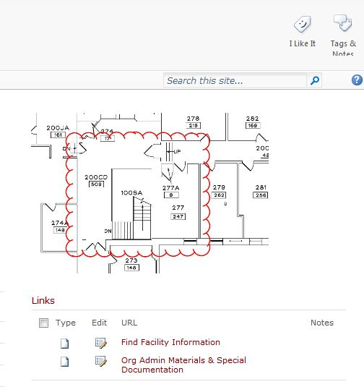

BE AWARE THAT THE LINK WILL OPEN IN THE CURRENT BROWSER, IT WILL NOT OPEN A NEW ONE.

- You can use the back button to return to the FI Renovations page.

