Bulk Edit Instructions

CAUTION!!!!
Please be clear on what you’re requesting through Bulk Edit BEFORE you begin. We strongly recommend performing the task in the Training System before attempting it in Production.

Bulk edit is designed to ADD things or change the org status to the room detail page, if you want to bulk edit an item you have to search on it.

There are limitations to what Bulk Edit is designed to do. You may have to do a series of bulk edit tasks to be able to accomplish your desired end results.

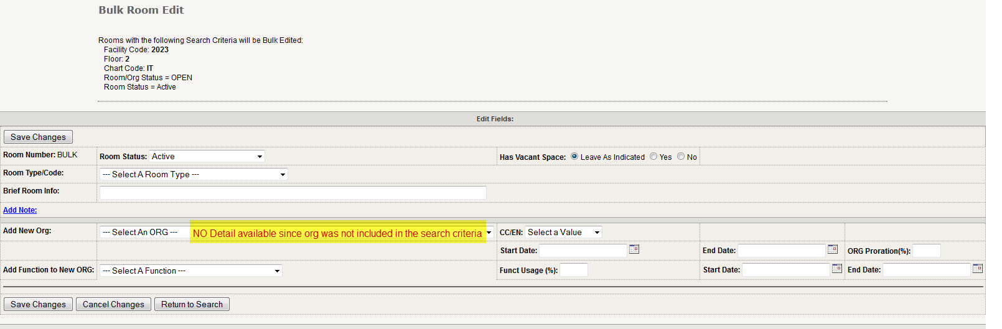
To initiate Bulk Edit you must do a room search and select the rooms you wish to edit. If you search without org code the Bulk Edit screen will appear like this:

If you wish to change fields related to org presence (fields found between the 2 lines below) you MUST include the org code within your search, this includes when adding an occupant.

If you include org code in your room search the Bulk Edit screen will appear like this:
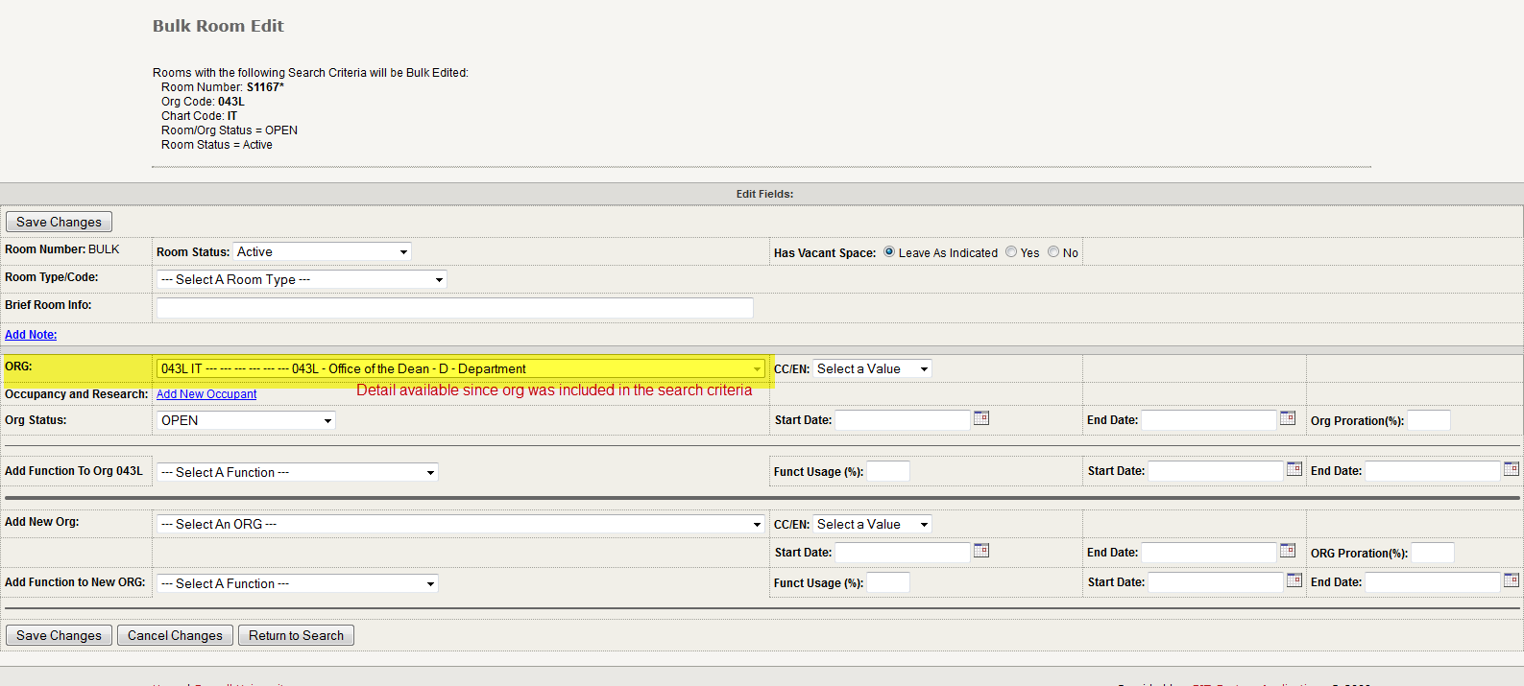

To add a new occupant from the above screen, select the Add New Occupant link.
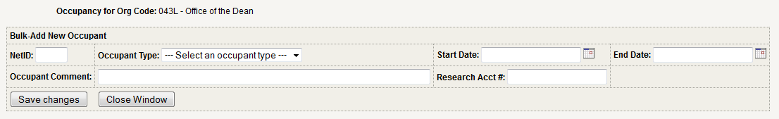

Bulk Edit - Add Note can be added from either type of search: The system will default to adding a note to note type “Room”, no other note types can be bulk added from the basic Bulk Edit screen.

Bulk Edit CAUTION for Org Admins:
If you’re helping your Department User by putting their org presence status to Hold for them, make absolutely sure that they are out of the records completely.
  - If you bulk edit records that are open by another user there is a high probability that all the changes made by the user will not be saved and errors previously cleared will return - for the entire set of selected rooms. There is no do over, the updates and corrections have to be put back manually.
    - Caution users about this problem, and confirm that they’re out of the records before you begin your bulk edit. Records already set to Hold and you’re bulk editing to Freeze are protected from this problem since users can’t change records in Hold.

