Facilities Inventory Standard Reports
https://oasprod.db.cornell.edu/analytics

- Building Occupants by Floor
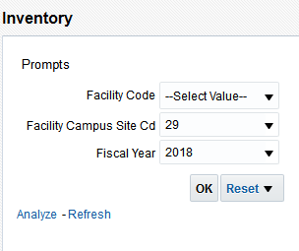

Lists Facility C-Level Org Occupancy by Floor
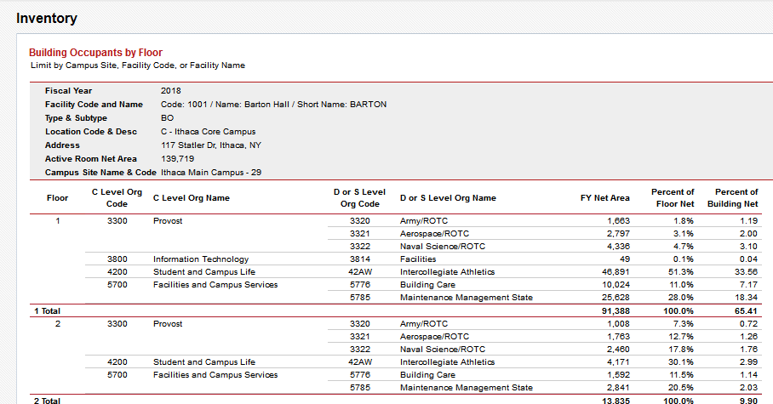
- Building Space Use by Room Type
Developed for Tom King
Combined
Summary
Detail
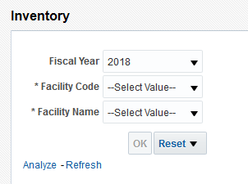

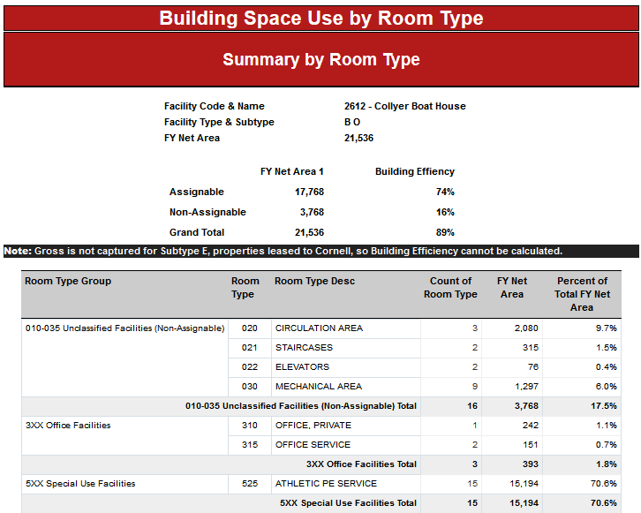

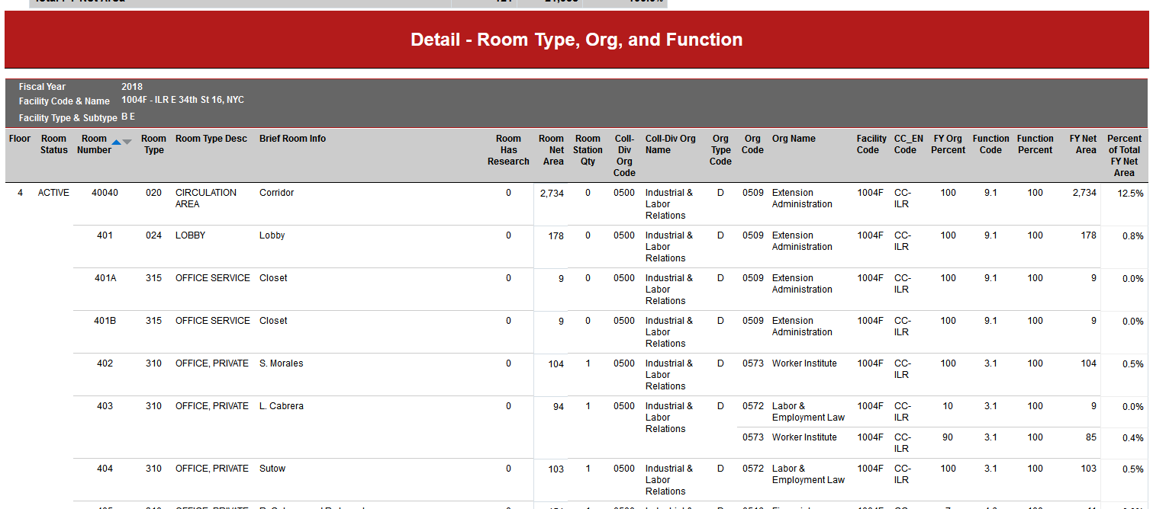

- College Finance Officers Budget Report by Building
Budget forecasting report -- two-year comparison by Building.
Developed for the Finance Office

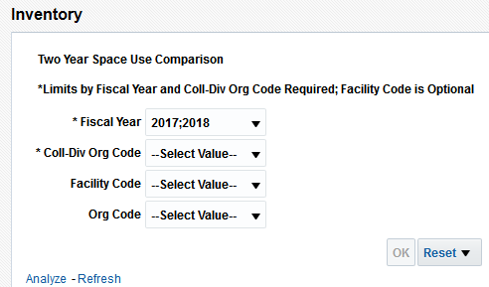

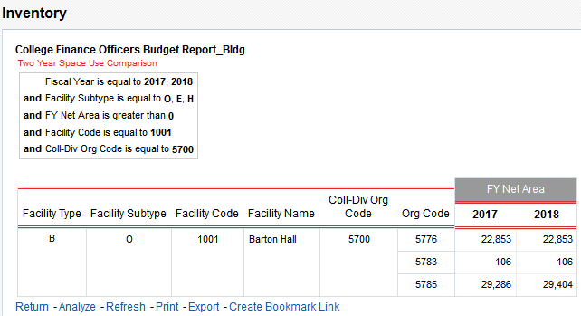

- College Finance Officers Budget Report by Org
Budget forecasting report -- two-year comparison by Org.
Developed for the Finance Office

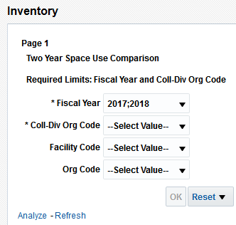

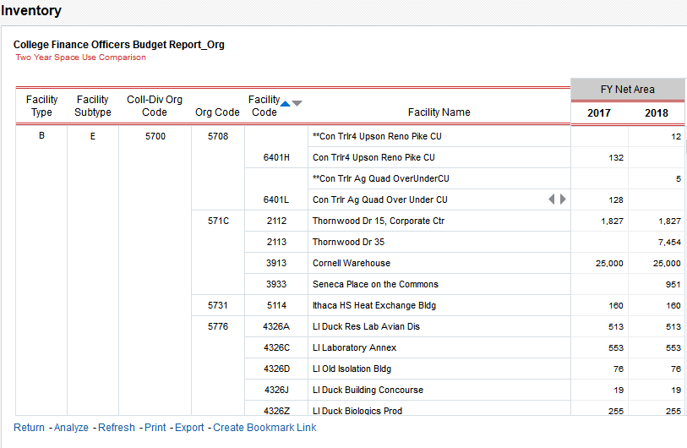
- FAC 100 Limited by C-Level Org
Facility Characteristics Report modified to limit to selected C-Level Orgs
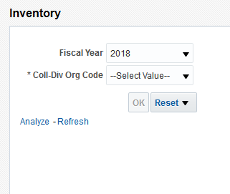

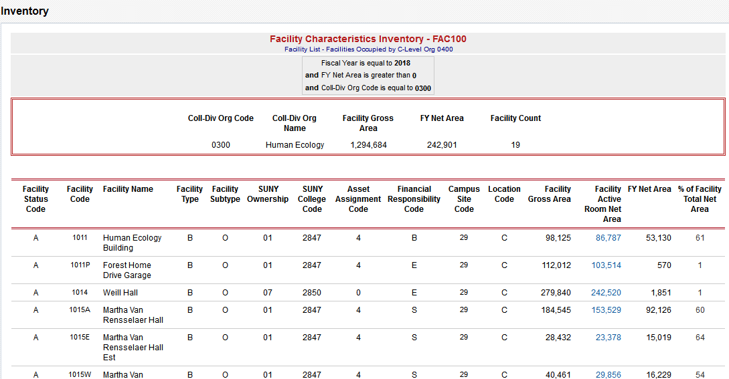

- Facil Room List – Pinnacle Reconciliation
Developed for Pinnacle facility clean-up

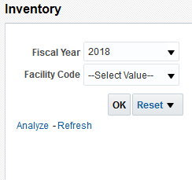

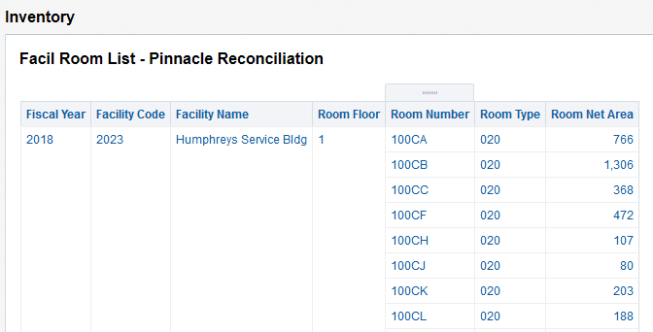

- Facil Room List with Brief Room Info
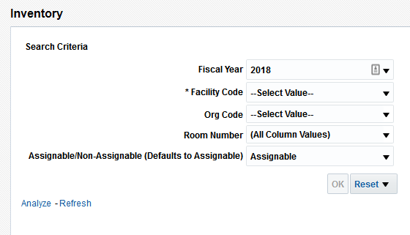

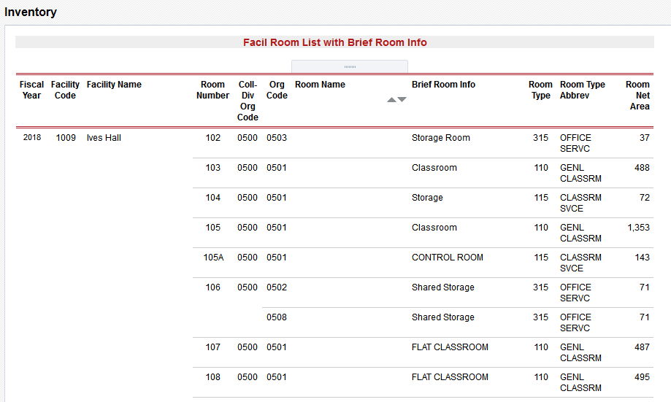

- Facilities Assignable Space by C-Level Org – jbv
Developed for Jane VanDerzee
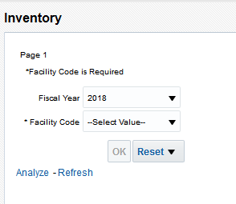

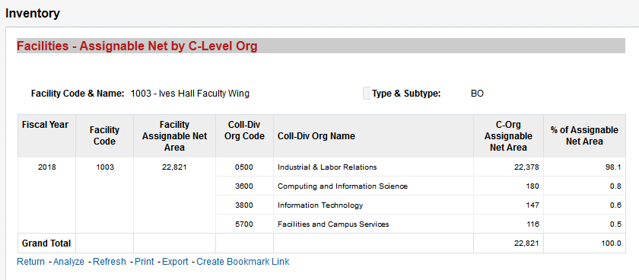

- Facilities Finance Budget Model Support
Developed for the Finance Office
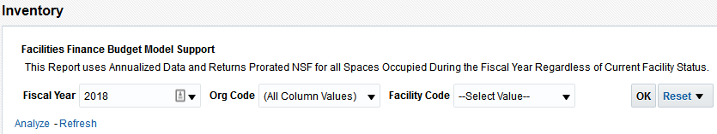

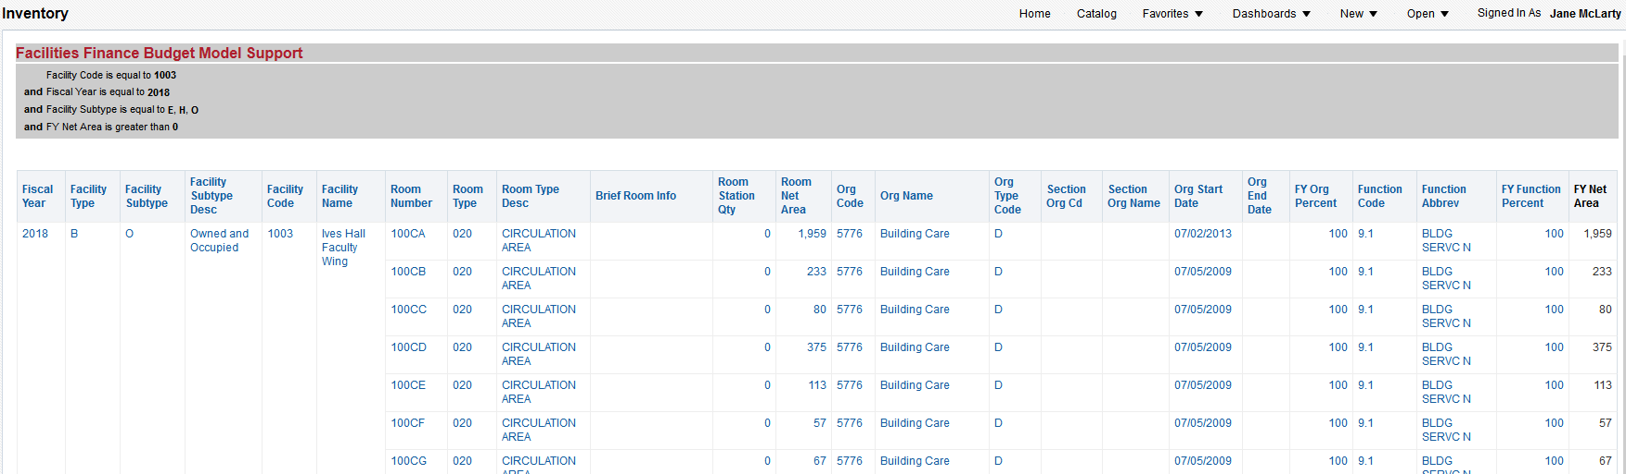

- Facilities Finance Global Facility Lookup
Facility Look-Up with Detailed Prompts

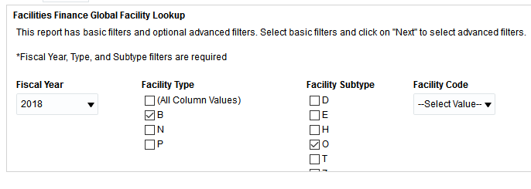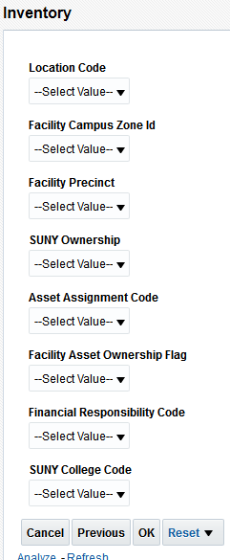
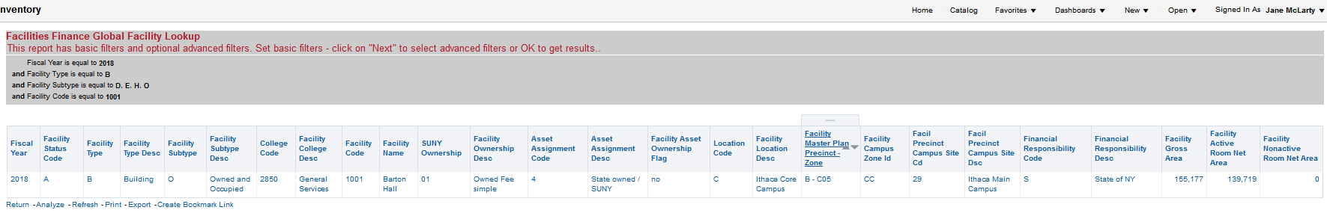

- Facilities Finance Global Room Lookup
Facility Look-Up with Detailed Prompts

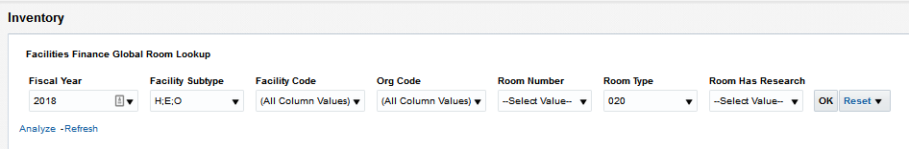

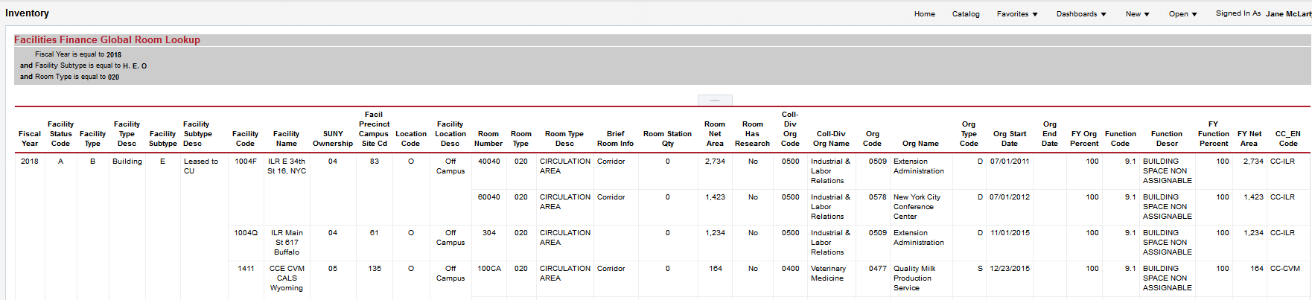

- Facilities Occupied by Selected C-Level Orgs
List of facilities with space coded to selected C-Level Orgs
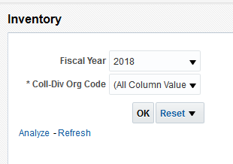

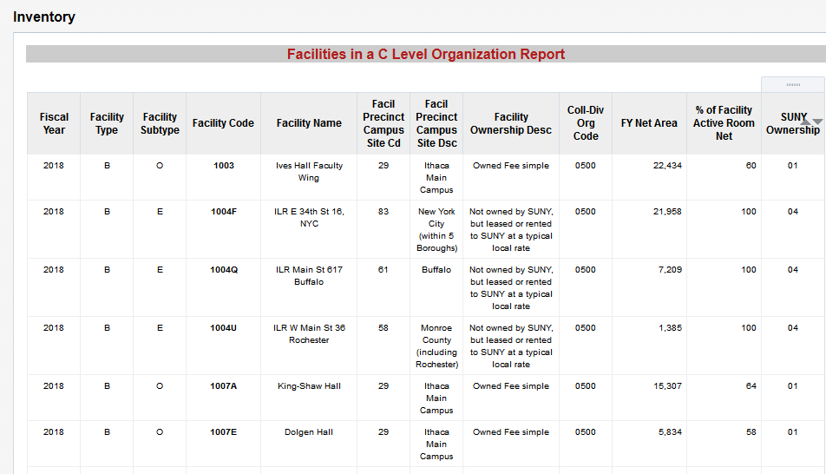

- Facilities with Dominate C-Level Org
List of C-Level Orgs by building with percentage of occupation; used to determine the dominant Org a building

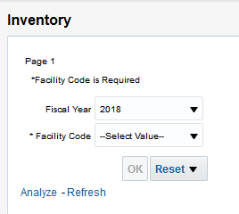

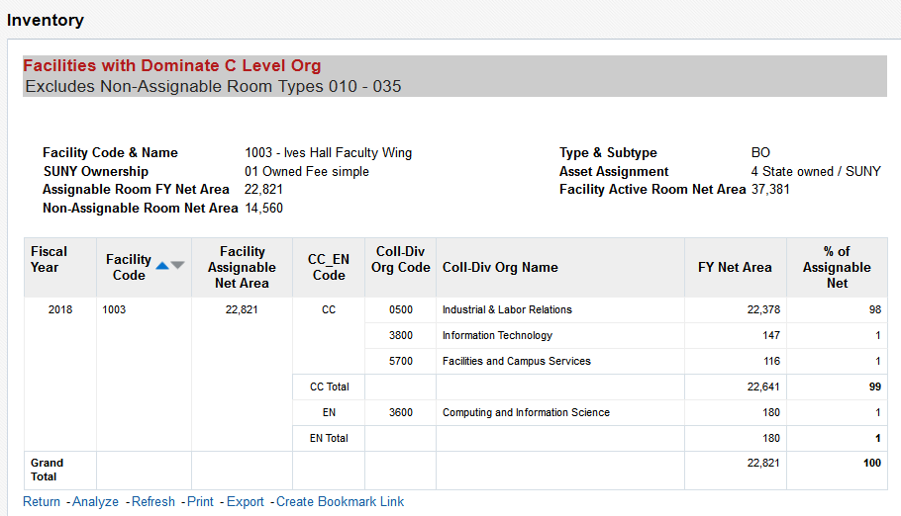
- Facility Active Room List

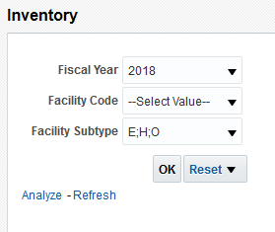

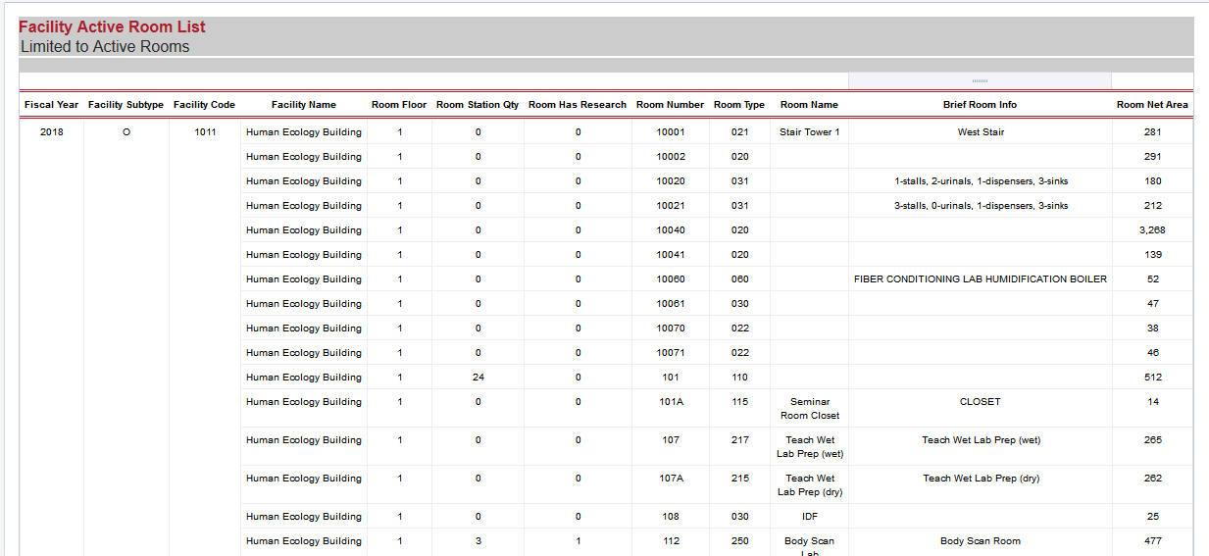

- Facility Names and Nicknames
No prompts
Generates a list of facility names and nicknames as held in the Facilities Inventory Database.

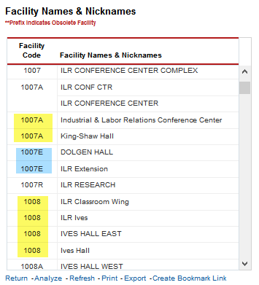

- Facility Occupancy and Construction Date
FAC 100 with construction date and occupancy date
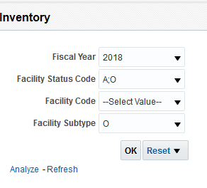
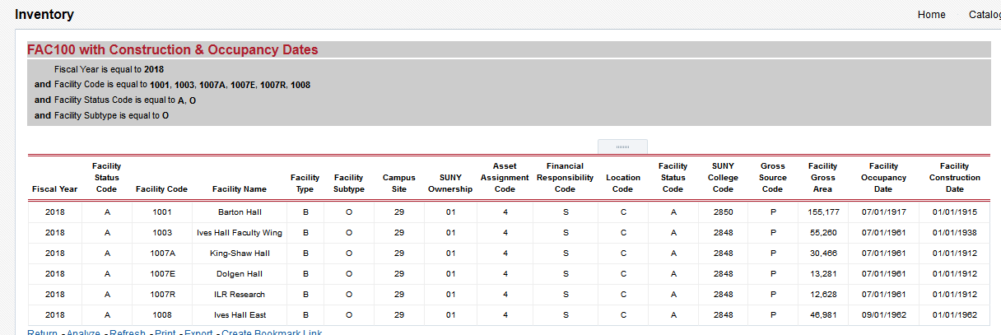

- Facility Street Address

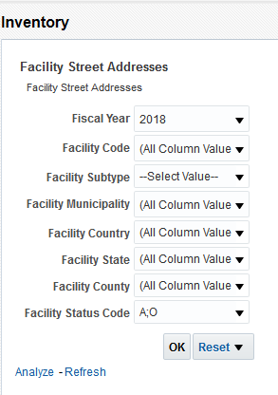

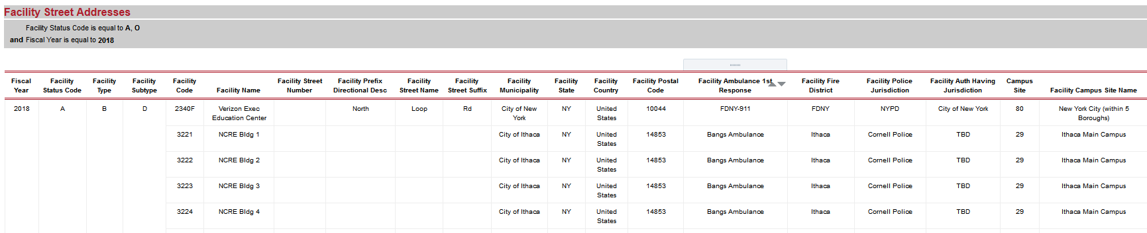

- Legacy Budget Model
Developed for Finance Office
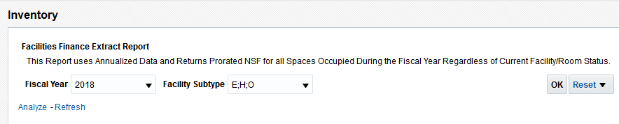
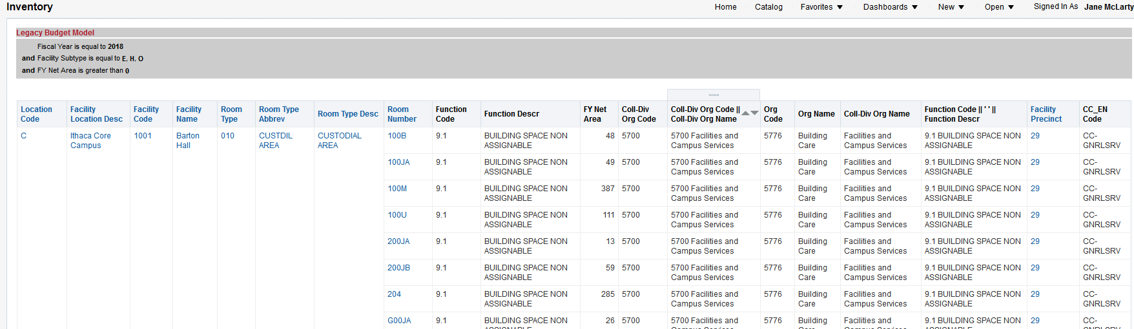

- Outside Use 7.2 SUNY Facilities
Developed for Karen Kunz

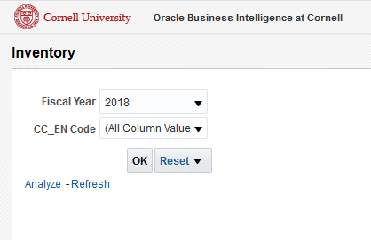
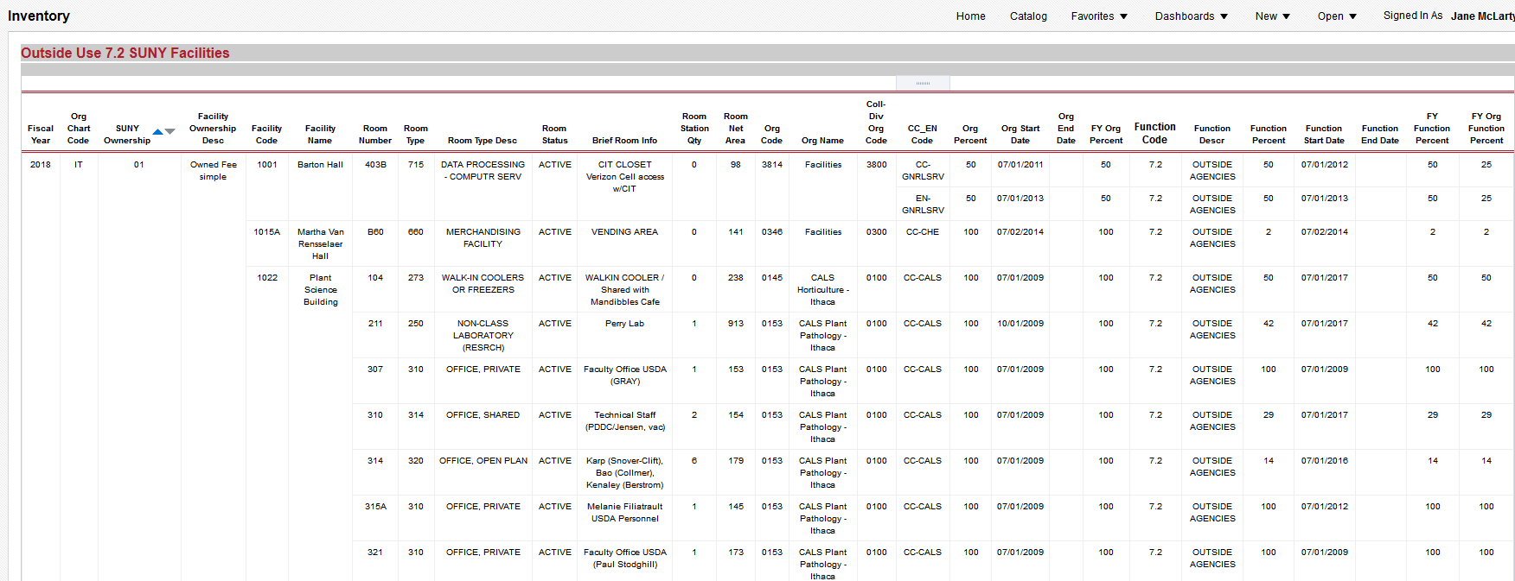
- PAR Section 10 Occupying Orgs
Provides information about occupants in Facilities undergoing renovations; developed for project managers.

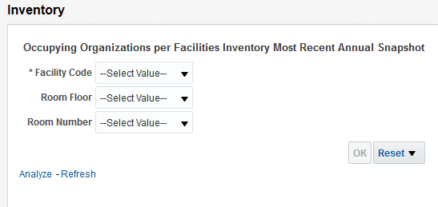

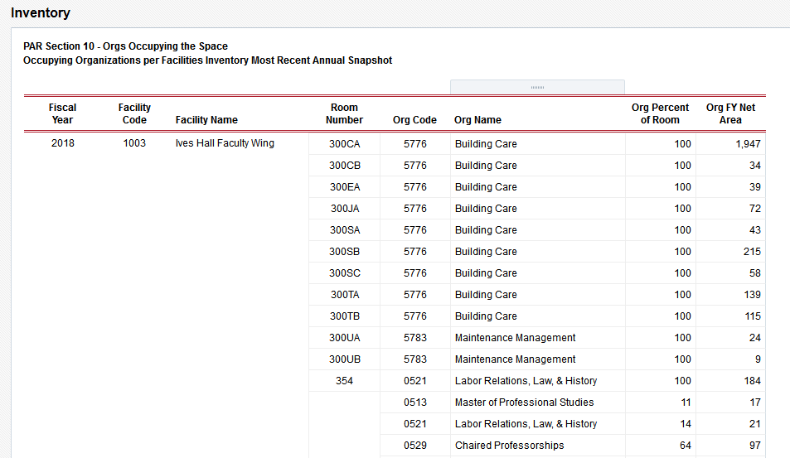

- PAR Section 10 Space Usage
Calculates the information needed to complete PAR Section 10; developed for project managers.

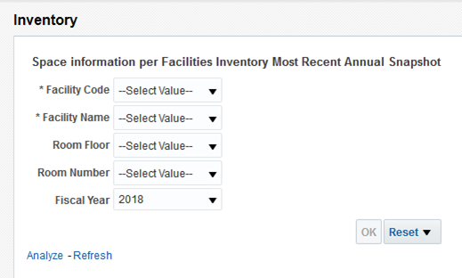

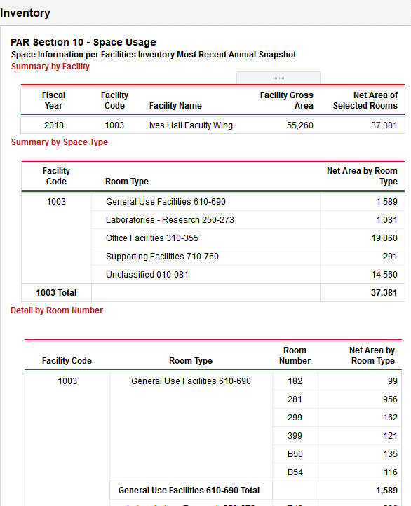
- Space Reports by D or S Org
Developed for Margaret McFadden
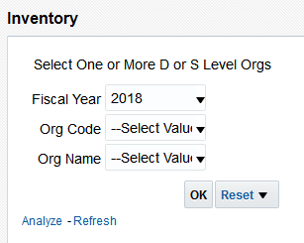

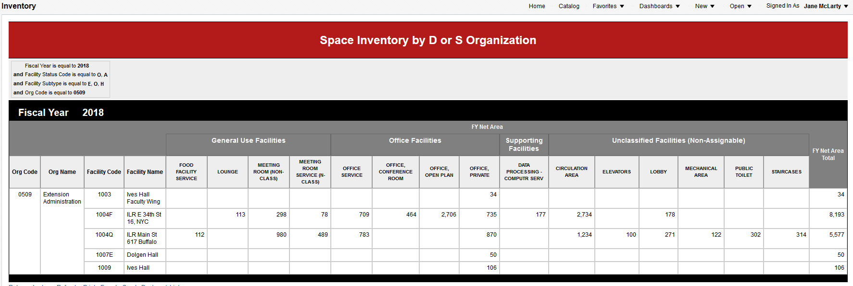

- Space Reports by Facility
Reports developed for Margaret
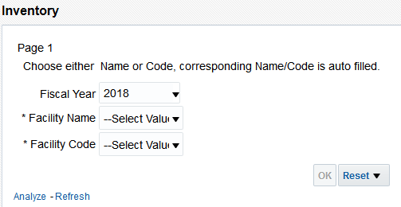

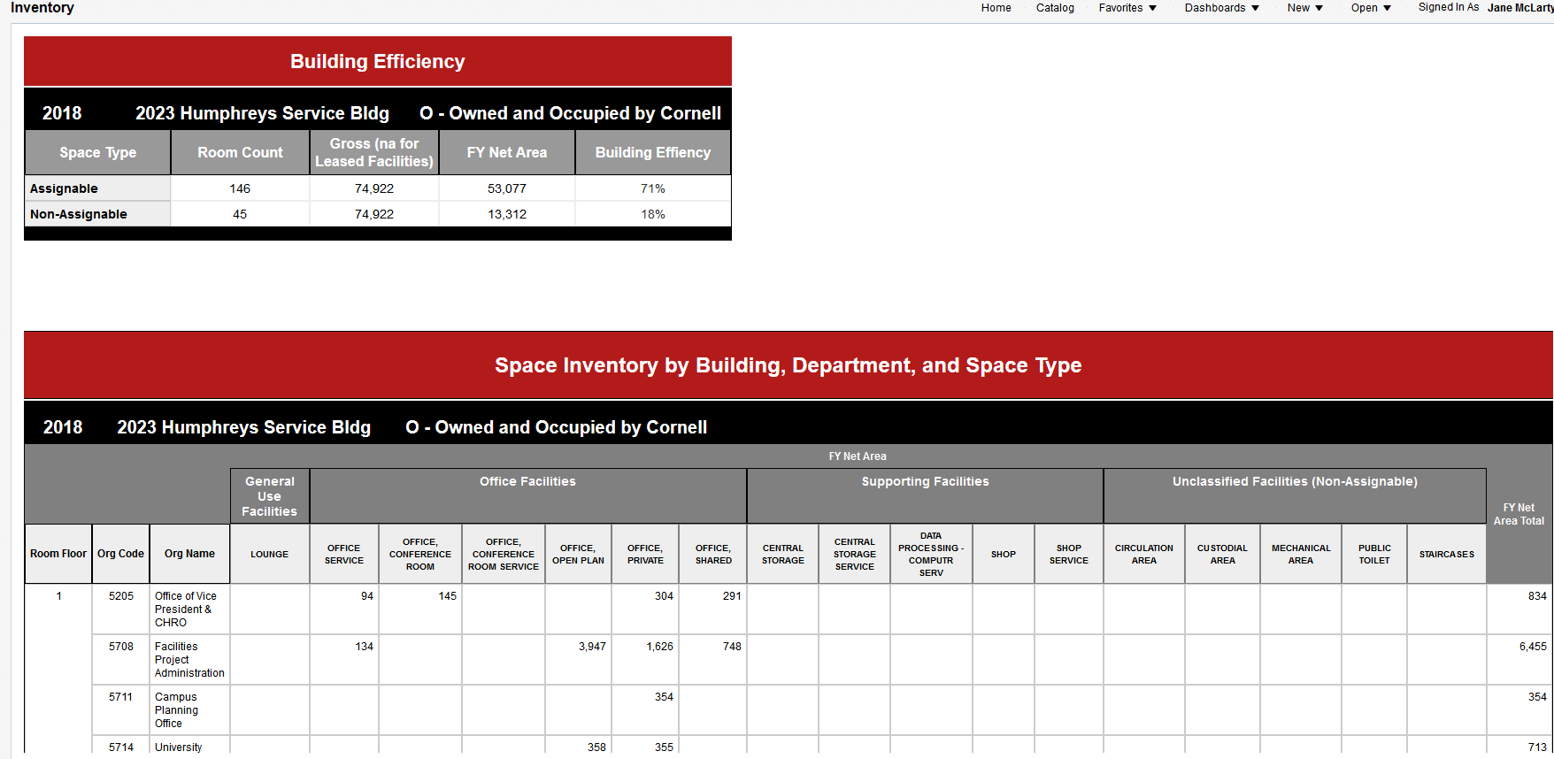

- SUNY BCI Report
Reports SUNY BCI Information
This report displays the BCI information collected by SUNY until 2016, limited to facilities with a Contract College presence

